EE 546C Lab 9

Data Capturing

May 29 at ECE137B

Learning objectives:
Lab 8 and 9 are highly flexible, allowing you to work on areas you feel still need improvement.
- Continue working on customized visualization.
- You are encouraged to use machine learning to process your data, this lab session can be used to process the data you collected.

Materials:

- Your laptop
- Lab kit

Tools will be provided:
- Calibration weights: 10g, 20g, 50g, 100g, 200, 500g
- Multimeter, oscilloscope, power supply
- Soldering station
- Scissors, wire strippers, IDC cables, crimpers, etc

Step-by-step machine learning resources:

Platform & Libraries Overview
Google Colab is a runtime platform, while PyTorch and Scikit-learn are two commonly used machine learning libraries. You can use PyTorch and Scikit-learn directly on Colab to develop and run your machine learning models without installing anything locally.

Google Colab
Overview:
Google Colab is a free, cloud-based Jupyter Notebook environment that supports Python and offers GPU/TPU acceleration.
Learning Resource:
- Marqo.ai Written Guide
- YouTube Video Tutorial
Key Features:
- No installation required.
- Free access to GPUs and TPUs.
- Seamless integration with Google Drive for saving and sharing notebooks.

PyTorch
Overview:
PyTorch is a deep learning framework developed by Facebook, widely used in both research and production. It supports dynamic computation graphs and GPU acceleration, making it flexible and powerful for building neural networks.
Learning Resource:
- PyTorch Official Tutorial
Key Features:
- Introduces tensors, autograd (automatic differentiation), and neural network construction.
- Ideal for beginners with no prior PyTorch experience.

Scikit-learn
Overview:
Scikit-learn is a Python-based machine learning library that provides efficient tools for data preprocessing, classification, regression, clustering, and dimensionality reduction.
Learning Resource:
- Scikit-learn Getting Started Guide
Key Features:
- Structured (tabular) data analysis.
- Rapid development and evaluation of traditional machine learning models.

Reminder for final presentation and demo on June 5:

Please submit the slides before 2:30pm on June 5.
The presentation will take place in EE137B, using the monitor for your 10min presentation, followed by a 5min live demo using your computer and/or the lab’s electronic instruments on the table in front of the screen.
Please confirm that your computer can connect to the monitor via High-Definition Multimedia Interface (HDMI). If needed, please prepare the adapter by yourself.
The order of the presentation and demo will be determined by random drawing during the lab session on May 29.
If needed, please set up and debug your system in advance before the presentation. Due to the limited time, we will start the presentation sharply at 2:30pm. If your setup requires any special assistance, please let the TA know in advance.
More information can be found in the Syllabus and in the Rubric.

Presentation and demo rubric and sequence:

Assessment Rubric

Sequence:

Sequence | Group Members
5 | Mia; Siena
6 | Nithish; Zhaohui
2 | Helen; Mingzhuo
4 | Juliette; Ritesh
1 | David; Tommy
7 | Chinmay; Eli
3 | Feier; Sean

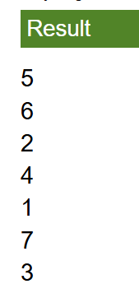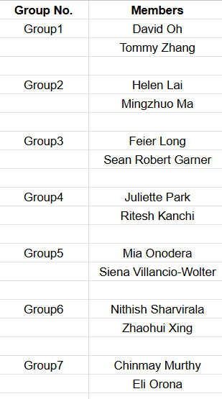

Survey for the development of a tactile sensor toolkit:
https://forms.gle/Qeoy9vMLkFHvMZCF8
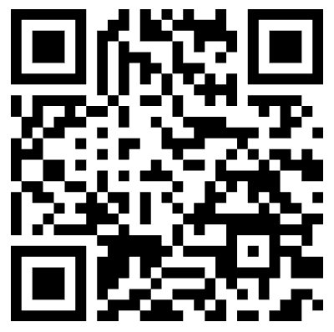

References:
- PyTorch. (n.d.). PyTorch: Tensors and autograd. Retrieved from https://docs.pytorch.org/tutorials/beginner/pytorch_with_examples.html
- Scikit-learn. (n.d.). Getting started with scikit-learn. Retrieved from https://scikit-learn.org/stable/getting_started.html
- Marqo. (2023, April 4). Getting started with Google Colab: A beginner’s guide. Retrieved from https://www.marqo.ai/blog/getting-started-with-google-colab-a-beginners-guide
- freeCodeCamp.org. (2022, October 6). Google Colab tutorial for beginners [Video]. YouTube. https://www.youtube.com/watch?v=rsBiVxzmhG0

